Christiaan Versfeld, Muhammed Bhula, Ruan Zwarts, Phuti Motimele

[ST10091991@vcconnect.edu.za](mailto:ST10091991@vcconnect.edu.za), [ST10073908@vcconnect.edu.za](mailto:ST10073908@vcconnect.edu.za), [ST10158660@vcconnect.edu.za](mailto:ST10158660@vcconnect.edu.za), [ST10191686@vcconnect.edu.za](mailto:ST10191686@vcconnect.edu.za)

Abstract

A detailed research document that is made for OPSC POE PART 1 Planning and design aspect that undergoes the application knowledge of what has been gained from the research aspect in designing the application as a whole.

OPSC Group E

Research - ClockSavvy

**Table of Contents**

# Introduction

# Applications

## Application Overview

## Application Innovative Features

# Detailed List of requirnements

# UI Design

# Project Plan

# Conclusion

7 Reference List

## **1.Introduction**

To design and implement a time management application we need to understand the fundamentals of what makes a time management a time management app. Each application has its own unique feature or design it follows to make the application much more effective and special in its own ways. Now that the theoretical aspect has been covered its time to jump into the practical aspect of the study.   
In this planning and design report we will be covering the technical design and aspects associated in developing a time management application. The theoretical features that have been discussed will be implemented on the practical aspect to ensure consistency and alignment between theory and practice.

## **2.Application**

**2.1. Overview**

**Application Logo:**

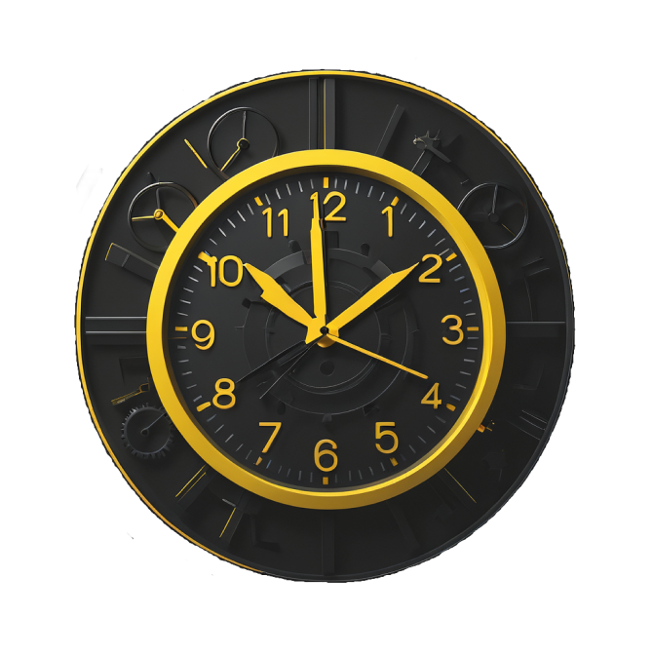

Application Name: ClockSavvy

**2.2. Innovative features of the application**

**Automatic Time Tracking**

This feature will consist of an automatic timer using a start and stop mechanic which will track time spent for each task/activity.

This will be beneficial as it will limit human error of manually logging the time spent. It provides a convenient way of tracking that will be much more accurate and hassle-free.

**Bulk Editing**

This feature allows users to edit and delete time entries and tasks in bulk which saves time and effort of doing each one separately. This is a great feature to have for convenience and makes using our time tracking application more appealing without the tediousness.

**Offline Tracking**

This feature will allow users to use the time tracking features of our application with no internet connection. The data will be stored locally so it is not lost and once the user has internet access again, the data will be synced with the cloud. This is a crucial feature to implement as data loss due losing internet connection is problematic as it wastes time and effort.

**Email Notifications**

This feature will implement notifications sent to user’s email instead of just in-app messages. The benefits of having an email notification system are users do not need to access the app to view when a deadline is upcoming, or a new task has been added etc. It is much more convenient for the user to receive these notifications by email.

**Integrated Calendar**

This feature will enable integration between the user’s phone calendar and the in-app calendar. The benefit of this feature is that the integration will automatically add the reminders from the in-app calendar onto the user’s phone calendar making it an automatic process where the user does not need to manually add these reminders into their calendar. It is much more convenient and ties into our app’s overall idea of being convenient to use.

## **3. Detailed list of requirenments**

**Functional Requirements:**

**User Authentication and Authorization:**

* Users should be able to register a new account and log in to the account securely.
* There should be a forgot password option in case a user forgets their password.
* And the password will be recovered via email verification or security questions.

**Dashboard:**

* There should be an intuitive dashboard that displays all relevant information such as tracked time, projects, categories, and tasks.
* There should be an option for customization for users to change the look and feel of the dashboard according to their preferences.

**Time Tracking:**

* Users can enter timesheet entries specifying the date, time.
* Users should be able to start, stop, pause, and edit time entries.
* There should be an option for users to manually enter time or use a timer.
* Users should have the ability to assign time entries to specific projects, tasks, categories, or clients.

**Project and Task Management:**

* Users should have the ability to create, edit, and delete projects and tasks.
* Users should have the ability to assign tasks to project members with deadlines and priorities.
* There should be a link between tracking time spent on each task and project.

**Reporting and Analytics:**

* There should be reporting, and analytics features for users to generate detailed reports on time tracked, projects, tasks, and clients.
* The features should be extensive allowing different types of reports such as timesheets and project summaries.
* There should be visualisation of data through charts and graphs.

**Integration:**

* There should be Integration capabilities with third-party tools such as project management software, calendar apps, and payment gateways.

**Notifications:**

* There should be a notification system in place for reminders, overdue tasks, and approaching deadlines, using in-app and email notifications.

**Settings:**

* There should be personalization options such as language, time zone, date format, and theme.

**Gamification:**

* There should be gamification elements such as badges or rewards for meeting or exceeding goals.
* Users can track their progress over time, unlocking achievements as they reach milestones and complete tasks way before due time.

**Non-Functional Requirements:**

**Security:**

* There should be Encryption for sensitive data such as user credentials.
* There should be access control to prevent unauthorised access.

**Performance:**

* The application should be fast with a responsive interface for a smooth experience.

**Reliability:**

* The application should have high availability with minimal downtime.
* Data should be backed up regularly to prevent data loss.

**Usability:**

* The Intuitive user interface should be user-friendly and easy to navigate minimising the hassle of learning to use the application.

**Compatibility:**

* The application should have full android compatibility.
* The application user interface design should be made for optimal viewing on different android screen sizes.

**Scalability:**

* The application should be designed in a scalable manner to handle future user base growth and increased data volume.
* The overall architecture of the application should be able to accommodate future enhancements and integrations.

**4. UI Design**

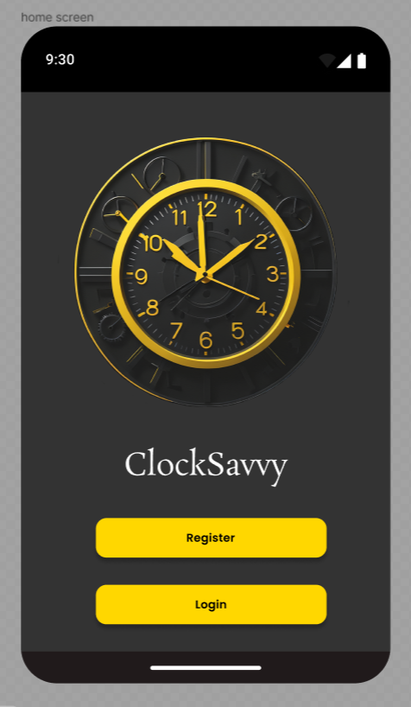

**Home Page**

This is the first screen upon opening the application. It acts as a home/welcome page displaying the name of our application ‘ClockSavvy’ and our logo.

There are two options available “Register” and “Login”.

Each button will take the user to the desired page such as for new users, to the registration page where they will be able to create an account and the login page for returning users to fill in their credentials and sign in.

**Registration Screen**

This is where new users will be able to create an account. The user will enter in their details securely such as their email and password which will be used to login to their account each time they choose to use our application.

**Login Screen**

Allows users to log into their account, this is after they have been to the registration page and created an account alternatively for returning users this screen can be accessed directly from the home screen. This is a secure login only for registered users and will allow them to begin using the application.

**Dashboard (Categories)**

The dashboard has 2 screens the user can select ‘Categories’ and ‘Tasks’ which will display each. There is a drop down which will filter the display ‘Current’ will show the current categories. The user will be able to go into each category by tapping on a category which will allow them to view it for editing or deleting. There is a plus icon next to the ‘categories’ text which will task the user to create a category screen allowing users to create new categories.

**Dashboard (Tasks)**

This is the second screen of the dashboard that displays the tasks in the same way as the categories. Users can go into each task to edit or delete them. The tasks are also filtered using the drop down in the top left. Like the categories there is also a plus icon next to the ‘Tasks’ text which allows users to go into the create task screen where they can create a new task.

**Task and Category Creation Screen**

This screen allows users to create a new task by filling in details such as the name and description. The user is also able to choose a category from a drop down that the task is associated with. There is also a calendar on this screen where the user will select the date for the task due date. An image can also be added to the task making it more identifiable on the dashboard. Once the users have completed all of the above, they will ‘Create’ the tasks and it will be added into the dashboard. Once the user has successfully created a task they will be redirected to the dashboard.

**Deleting Screen**

Once the user has selected a task, they will be able to edit or delete it. This is the delete screen. The user can select the name of the task from the drop down and select the associated category from the drop down as well once they have chosen the relevant task and category, they can proceed to delete the task. Once the user has successfully deleted the task they will be redirected to the dashboard.

**Editing Screen**

Once the user selects a task, they will be able to edit the details of the tasks including the category. The user can select the project the task is a part of from a drop down, then edit the name of the task, the description of the tasks, the category the task is associated with, the due date and the image that was set to that task. Once all these or only some details have been changed the user will ‘edit’ the task and it will redirect them to the dashboard where they can view the updated task details.

**Reporting Screen**

The user can access this screen by choosing the statistics icon at the bottom of the screen. On this screen the user will be able to generate a report by choosing or inputting in all the relevant details on the project they wish to generate a report for. Once completed a report will be generate and sent to the user’s email.

**Graph Display Screen**

The User can view the statistics of time tracked through the graph display at any point by accessing the statistics screen. This will be a detailed graphical display of time spent per task or project daily/weekly/monthly.

1. **Project Plan**

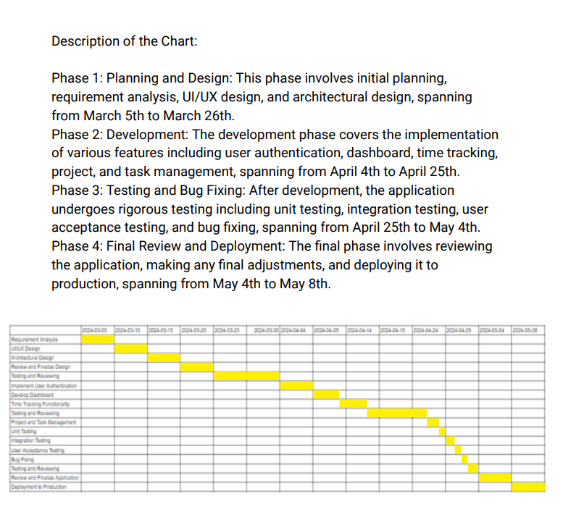

## **Conclusion** The application will implement multiple functionalities and processes that will allow the app to uphold the goals set upon the application. Multiple other app innovative features (from Timely, Harvest and Toggl Track) have been described and studied on how and why these features are successful and with these features understood as well as extensively researched on their specific advantages and disadvantages, the approach to making ClockSavvy (The application name) will be considered very carefully and implemented in a newer yet classical way with these supporting studies. With these studies set in place the architecture design will follow a complex design that will give ClockSavvy an edge in functionality ultimately automating the experience for the user in a back-end perception. In a front-end perception ClockSavvy will follow a classical look and feel making the user not feel overwhelmed and making the experience in a gamification form. The idea of ClockSavvy is to make it easier yet fun for the user to time manage their day-to-day timing experience and we aim to strive for these goals to be set in motion and place.

## **7.Reference List**

crozdesk (2024) *Timely | software reviews & alternatives*, *Timely*. Available at: https://crozdesk.com/software/timely (Accessed: 20 March 2024).

GetApp (2024) *TOGGL Track Reviews - Pros & Cons, Ratings & More | Getapp*, *Toggl Track*. Available at: https://www.getapp.com/project-management-planning-software/a/toggl/reviews/ (Accessed: 20 March 2024).

GetApp (2024a) *Harvest vs TOGGL track comparison | getapp*, *Harvest versus Toggl Track comparisons*. Available at: https://www.getapp.com/finance-accounting-software/a/harvest-time-tracking-and-online-invoicing/compare/toggl/ (Accessed: 20 March 2024).

Google Play (2024) *Timely automatic time tracking - apps on Google Play*, *Google*. Available at: https://play.google.com/store/apps/details?id=com.timeapp.devlpmp&hl=en&gl=US (Accessed: 20 March 2024).

Google Play (2024b) *TOGGL track - android apps on Google Play*, *Google*. Available at: https://play.google.com/store/search?q=toggl+track&c=apps&hl=en&gl=US (Accessed: 20 March 2024).

Harvest (2024) *Time Management Strategies that improve time management skills*, *Harvest*. Available at: https://www.getharvest.com/resources/time-management-strategies (Accessed: 20 March 2024).

Harvest (2024a) *Time tracking for those who value insight*, *Harvest*. Available at: https://www.getharvest.com/harvest-time-tracking?chan=Google&device=c&kw=%2Bharvest+%2Btimer&loc=1028682&camp=445034609&adgr=29583837809&type=brand&utm_term=%2Bharvest+%2Btimer&utm_campaign=EMEA%2BHarvest%2B-%2BBrand%2B-%2BAll&utm_source=adwords&utm_medium=ppc&hsa_acc=4436465424&hsa_cam=445034609&hsa_grp=29583837809&hsa_ad=649829003454&hsa_src=g&hsa_tgt=kwd-34467572804&hsa_kw=%2Bharvest+%2Btimer&hsa_mt=b&hsa_net=adwords&hsa_ver=3&gad_source=1&gclid=CjwKCAjwkuqvBhAQEiwA65XxQF1RL0JHTKcqfaz0wzT09vNfY83QMdMcOqgXy89iRzlxsGHK_YLvhxoCb8MQAvD_BwE (Accessed: 20 March 2024).

Replogle, N. (2023) *6 best time tracking apps in 2024*, *Zapier*. Available at: https://zapier.com/blog/best-time-tracking-apps/ (Accessed: 20 March 2024).

Santos, J.M.D. (2023) *TOGGL Track Review: Features, Pricing & User Reviews*, *project*. Available at: https://project-management.com/toggl-software-review/ (Accessed: 20 March 2024).

Santos, J.M.D. (2023a) *Harvest review: Features, pricing & user reviews*, *project*. Available at: https://project-management.com/harvest-software-review/ (Accessed: 20 March 2024).

Software Advice (2024) *Timely reviews*, *Timely Software Reviews, Pros and Cons - 2024 Software Advice*. Available at: https://www.softwareadvice.com/za/employee-monitoring/timely-profile/reviews/?review.rating=4 (Accessed: 20 March 2024).

Timely (2024) *AI-Powered Time Tracking Software*, *Timely*. Available at: https://timelyapp.com/#:~:text=Automate%20your%20time%20tracking,desktop%20app%20automatically%20for%20you. (Accessed: 20 March 2024).

Timely (2024a) *Ai timesheets*, *Timely Features*. Available at: https://timelyapp.com/feature/ai-timesheets (Accessed: 20 March 2024).

Timely (2024b) *Track time*, *Timely*. Available at: https://timelyapp.webflow.io/features/automatic-time-tracking (Accessed: 20 March 2024).

Timely (2024c) *The memory app - see everything you work on each day*, *The Memory App - See everything you work on each day*. Available at: https://timelyapp.com/memory-app (Accessed: 20 March 2024).

Timely (2024d) *Time Planning*, *Timely Features*. Available at: https://timelyapp.com/feature/time-planning (Accessed: 20 March 2024).

Toggl (2006) *TOGGL track: Time Tracking Software for any workflow*, *Toggl Track: Time Tracking Software for Any Workflow*. Available at: https://toggl.com/ (Accessed: 20 March 2024).

Toggl (2006a) *Time Tracking for Invoicing & Billing: Toggl track*, *Time Tracking for Invoicing & Billing | Toggl Track*. Available at: https://toggl.com/track/time-tracking-invoicing/ (Accessed: 20 March 2024).

Toggl (2006b) *Online time reporting software [free]: Toggl track*, *Online Time Reporting Software [FREE] | Toggl Track*. Available at: https://toggl.com/track/online-time-reporting/ (Accessed: 20 March 2024).